SoCal Tech Bridge Wraps-up First Iteration
of Project Vesta Experiment for Wildfire Response

CAMP ROBERTS, CALIFORNIA (FEBUARY 14 - 18, 2022) – NavalX SoCal Tech Bridge conducted its first experiment iteration for Project Vesta, during the Naval Postgraduate School’s (NPS) Joint Interagency Field Experimentation (JIFX) 22-2 aboard Camp Roberts, CA. Under the direction of NPS student Captain Ben Cohen, USMC, and the Project Vesta leadership team of SoCal Tech Bridge, CANA LLC, and TESIAC, the industry partners Arcimoto, BEAM, JuiceBar, HEN Nozzles, Komodo, Eirene AI, and Parallel Flight Technologies participated in experiments designed to address the severe and growing threat of wildfires. The goal of Project Vesta is the development of a semi-autonomous fire mitigation “system of systems'' prototype that combines state-of-the-art technology and Commercial-Off-The-Shelf (COTS) equipment that will predict or identify fire risk, shorten response times, enable localized atmospherics and real time situational awareness, predict fire movement and speed, and reduce risk to firefighters and first responders.
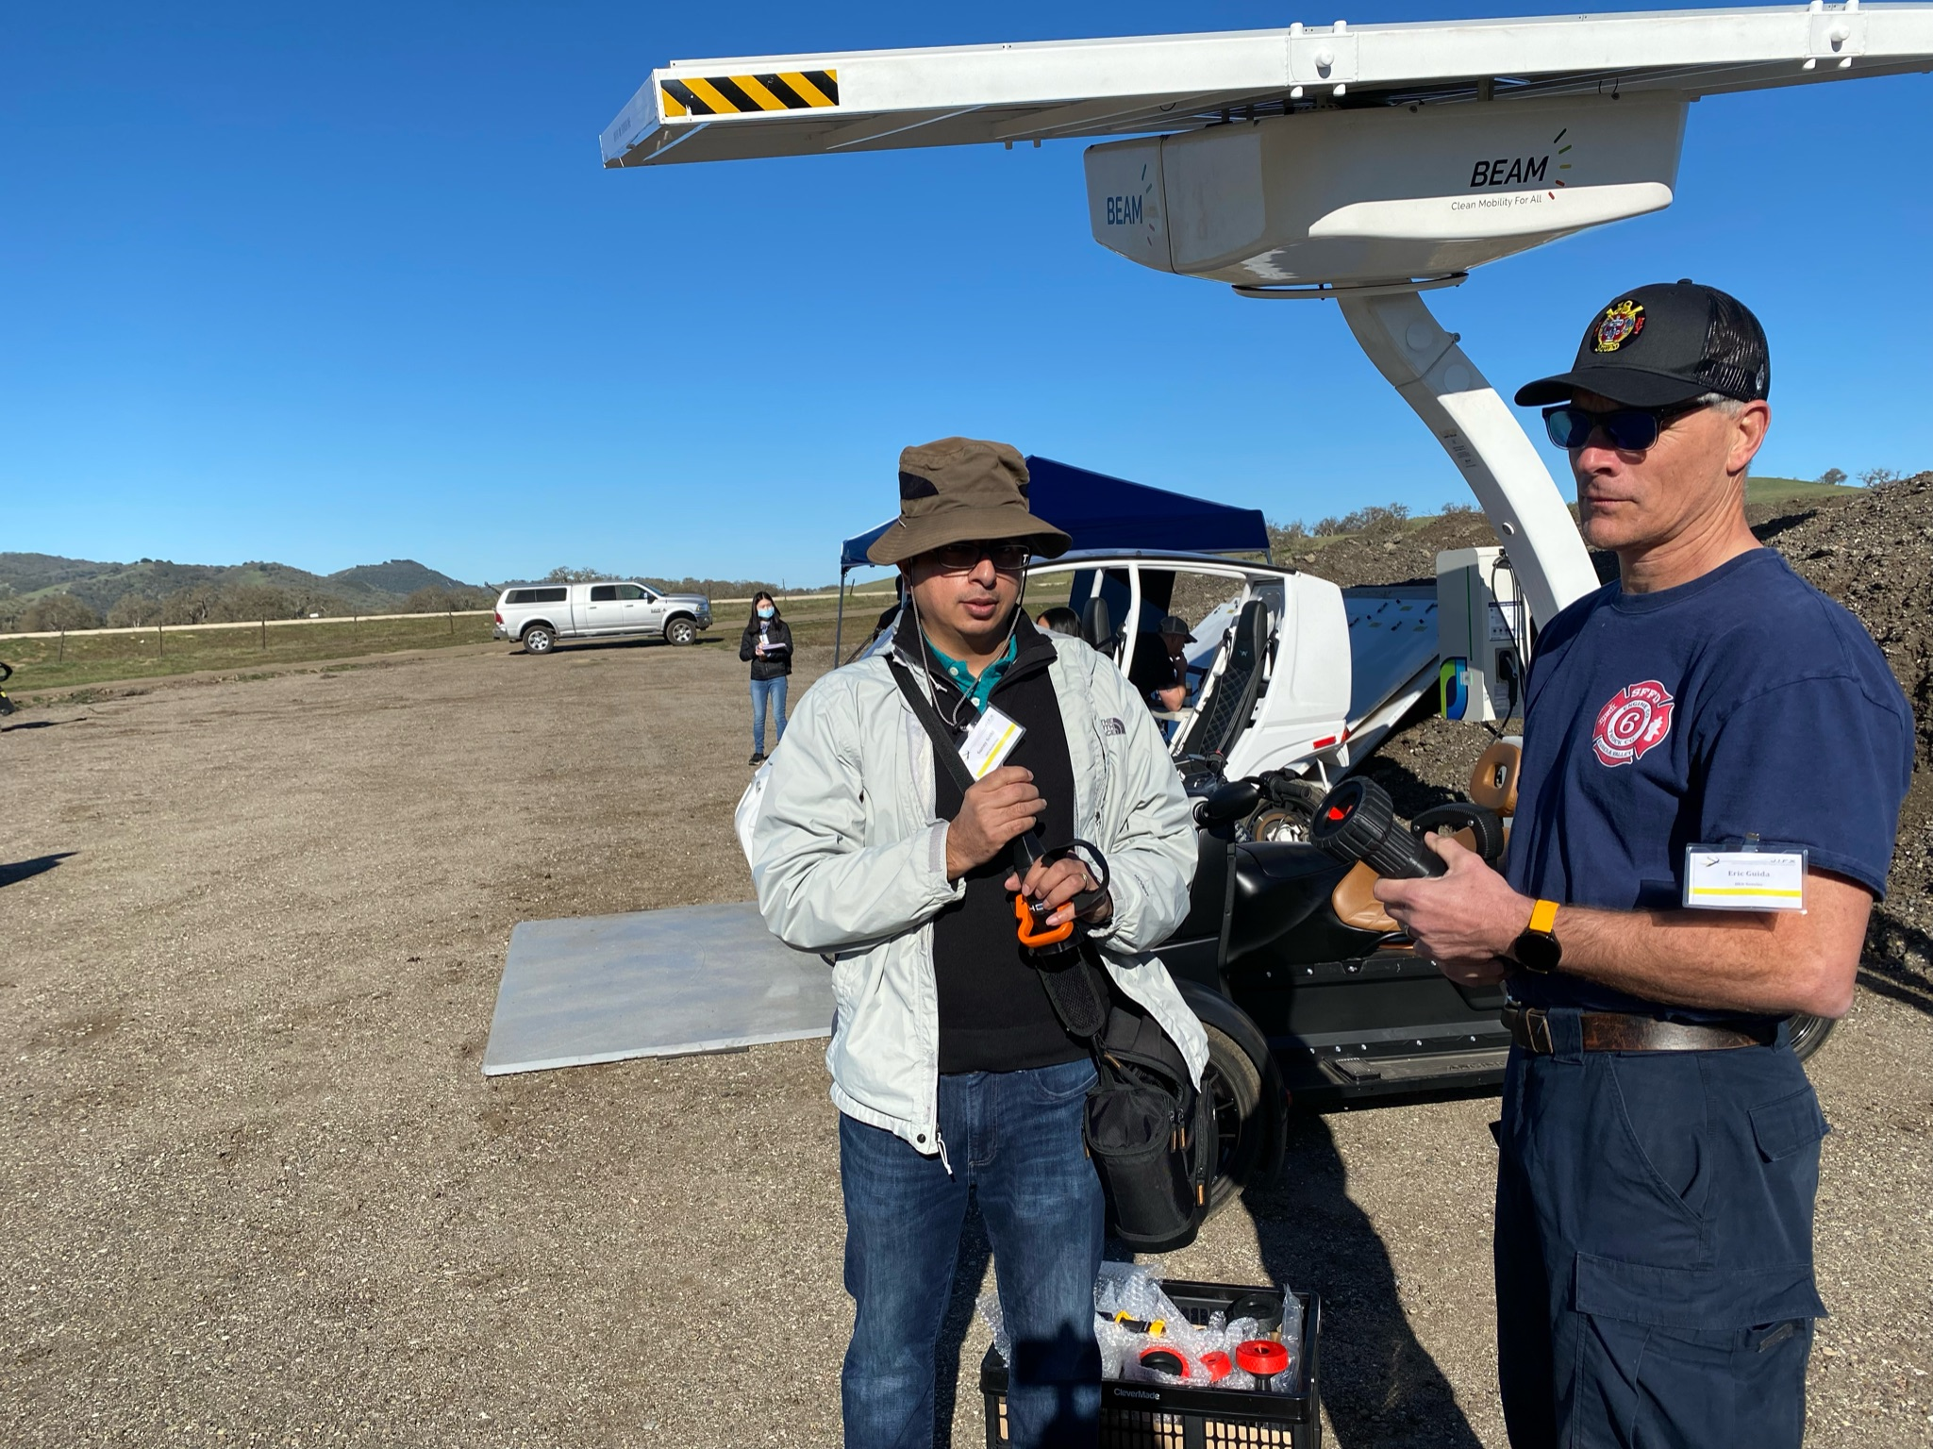
Hen Nozzles CEO Sunny Sethi coordinates with local fire chief with an Arcimoto Electric Vehicle and BEAM Charging Station in the background.
With the completion of this first week of integrated experimentation, a clear vision and path forward has been established. This JIFX 22-2 week consisted of four days of tests aimed at merging the technology and capabilities of COTS equipment, along with subject matter expert input from industry partners, professional firefighters, and interested stakeholders. The initial stage goal was to independently evaluate capabilities to predict, detect, locate, cue assets, suppress, and reduce controlled fire burns while utilizing electric mobility platforms and renewable energy.
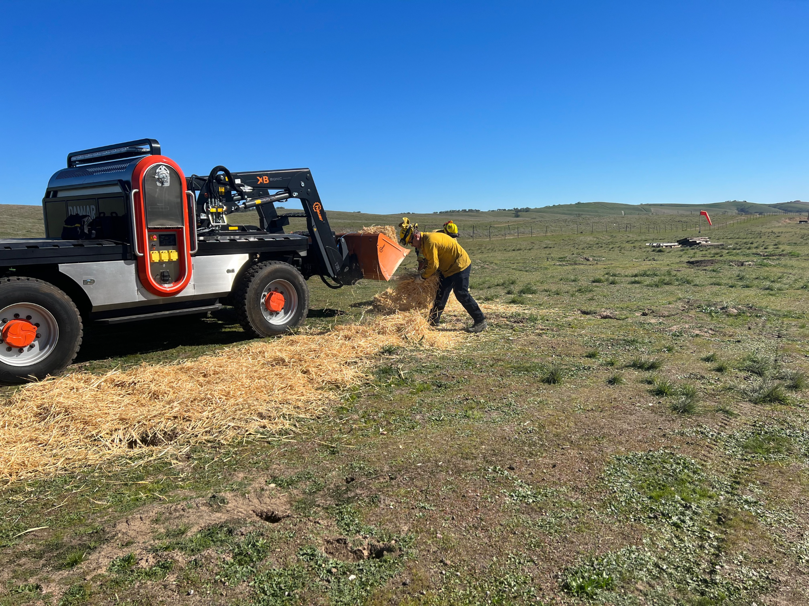
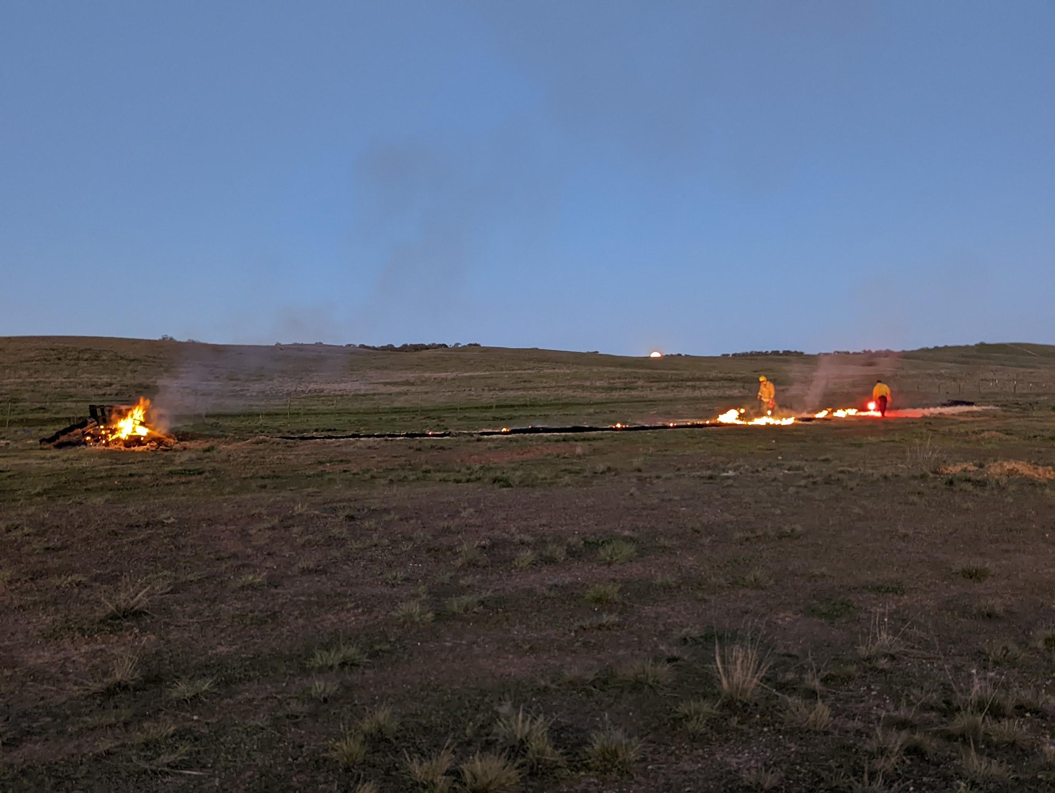
A DANNAR Autonomous Vehicle brings supplies.
Fires set aboard Camp Roberts for Project Vesta Experiment
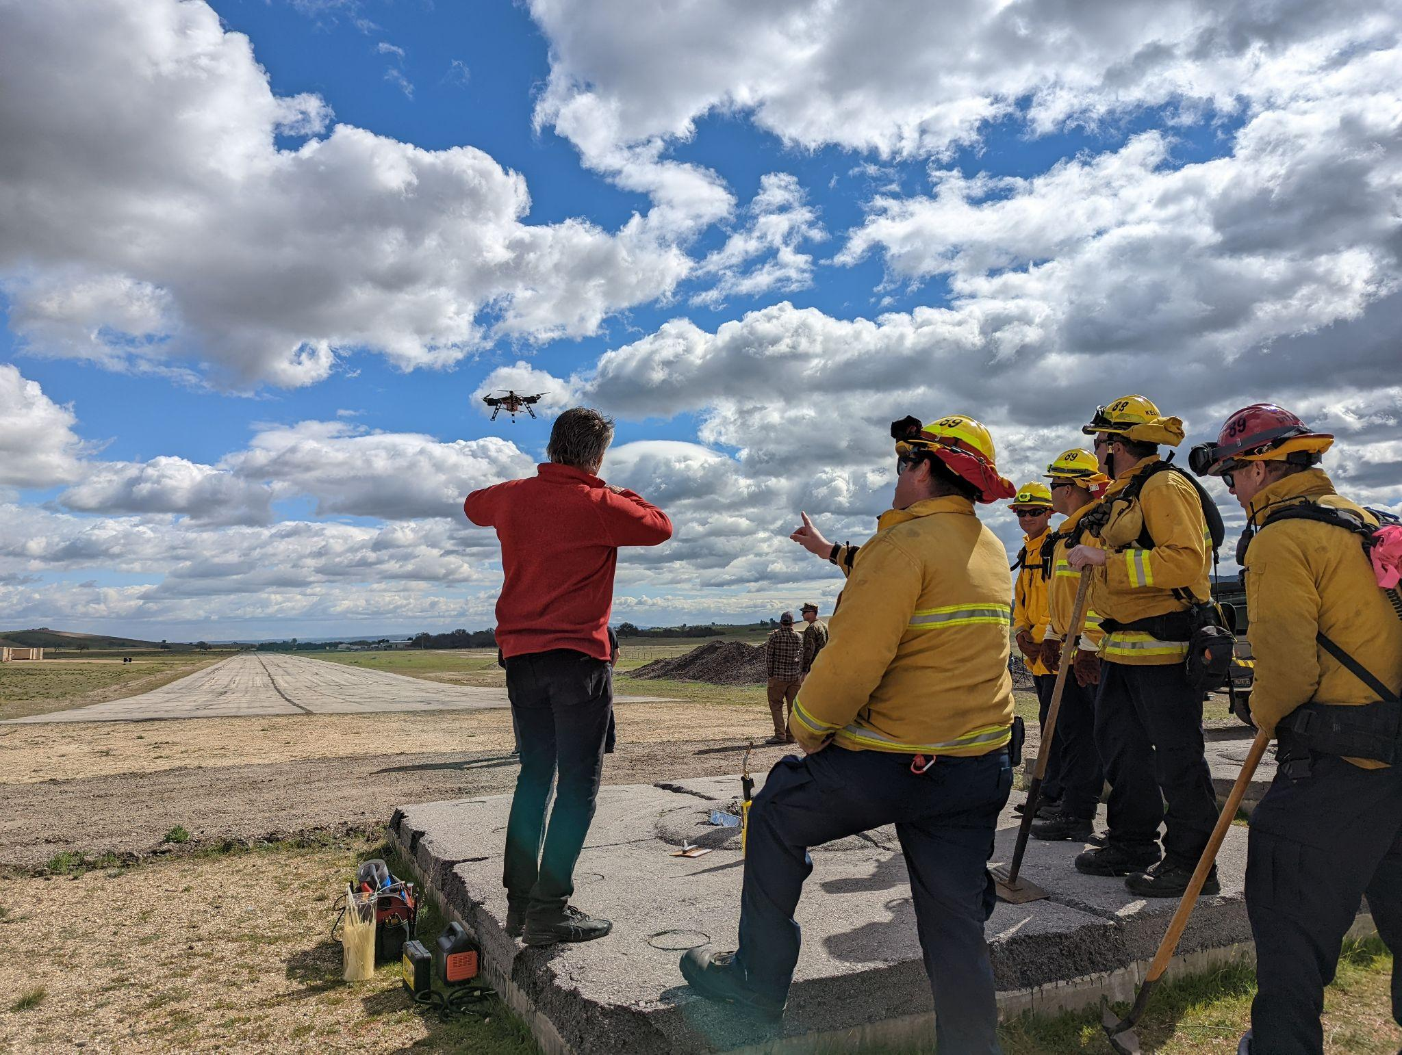
Firefighters observe the Parallel Flight Technologies drone.
The next iteration of the Project Vesta Experiment will take place in May with the interim time spent incorporating lessons learned, conducting market analysis to identify additional potential technology partners, and continued efforts to evolve and improve upon the Project Vesta model.

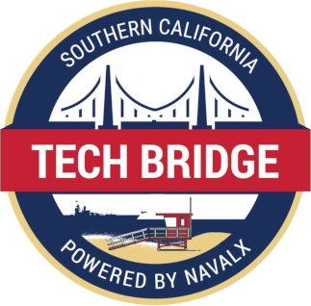

About SoCal Tech Bridge: The SoCal Tech Bridge leverages the Southern California convergence of Installations, Industry, and Research to unlock emerging technology through non-traditional partnerships. The SoCal Tech Bridge is built around the philosophy that collaborative markets can be established that enable mutually beneficial opportunities for the Department of Defense (DoD) and Commercial Industry to partner. These collaborative efforts are the foundation for a better business model unlocking the future of DoD Research & Development requirements development, and prototyping. Our technical focus areas - Installation Protection, Resilience, Mobility, Artificial Intelligence and Machine Learning, and Autonomous Systems - are woven throughout our collaborative efforts and vision. www.socaltechbridge.org

